CMPE 306

Spring 2020

Lab 10: Frequency Selective RLC Circuits

By: Nem Negash

April 24th, 2020

**Purpose**

The purpose of this lab is to study second-order frequency- selective circuits consisting of resistors, capacitors and inductors. These circuits are frequency-selective because the outputs due to input sinusoidal signals at certain frequencies have larger amplitude than the outputs due to input signals at other frequencies. Thus, the circuit selects certain frequencies (the high amplitude ones) in preference to other frequencies (the low amplitude ones). Such frequency selective circuits are the most common use for RLC designs. The addition of the second energy storage device, that is, adding the inductor to an RC circuit or the capacitor to an RL circuit permits us to design a frequency selective circuit that has a bandpass characteristic, in addition to the low pass and high pass characteristics demonstrated in Lab IX.

**Equipment**

1. LTSPICE

**Procedure**

* 1. **Series LRC Circuit #1**

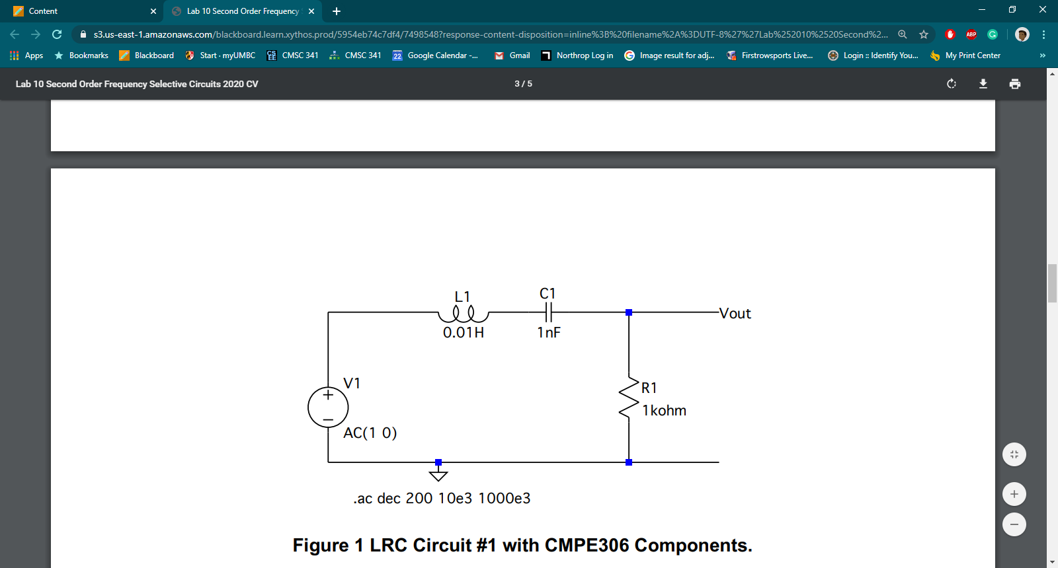

1. In the plot window that opens on the successful completion of your simulation, select V(vout). Notice the logarithm x-scale and the decibel y-scale. Notice that the figure shows a frequency selective band-pass circuit, with a peak response somewhat less than 10 kHz. Use the cursor to estimate the frequency of the peak (0 dB) response.

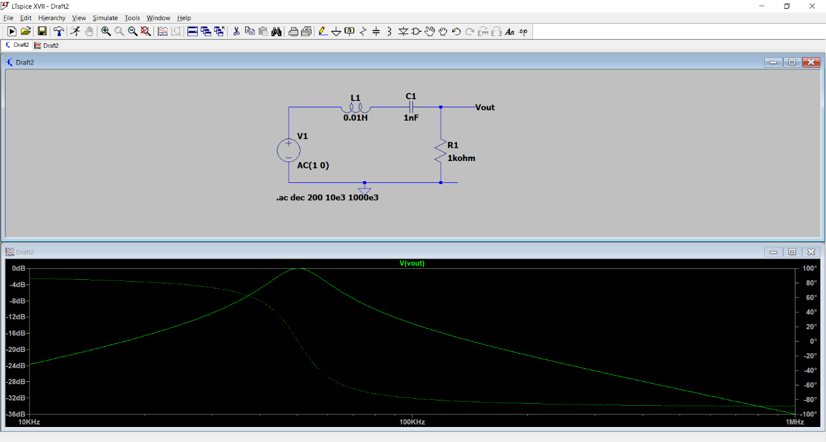

1. As we will see in class within the next week or so, the peak response of an LRC circuit is estimated by its resonant frequency, (the expression should look familiar! Computed in this manner, the units of the resonant frequency are in rad/s. Remembering that, compute the resonant frequency and compare it to value measured.
   1. Measured value: 501KHz Computed Value: 496KHz
2. Change the scale of the plot so that the y-axis goes from -3 dB to 0 dB, and the x-axis from 1 kHz to 25 kHz, while retaining the logarithmic scale. Estimate the width (in Hz) of the frequencyselective curve between the two -3 dB points. Compare this to the theoretical value obtained from , where the result of that division is in rad/s, not Hz. Provide the expanded scale plot, and your computations in your REPORT.

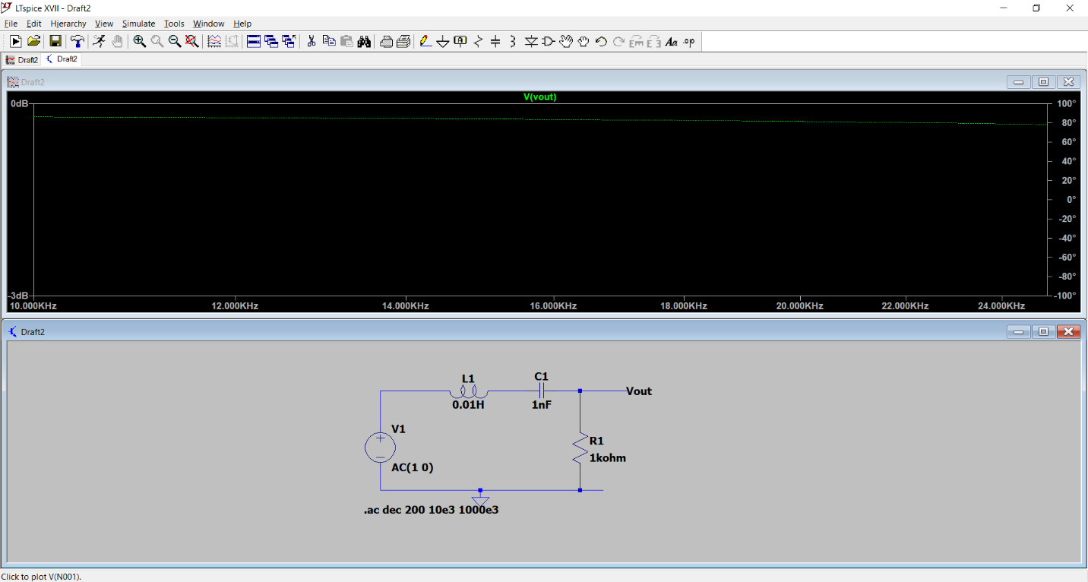

1. Using the equations for , B = L /R ,ω0 = sqrt(1 /LC) adjust the values of while holding constant so that the resonant frequency is changed to approximately 50 kHz. Modify the circuit to use the new component values. Save and print the modified circuit. Plot the results, then change the scale as in step 3 to estimate the -3 dB bandwidth. Compare your estimated value to the theory, as in Step 3.

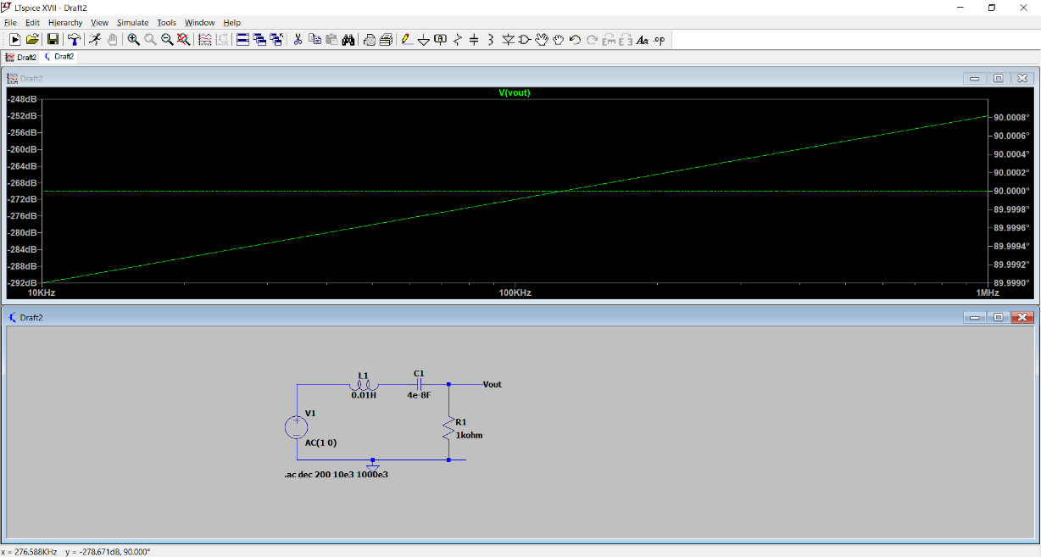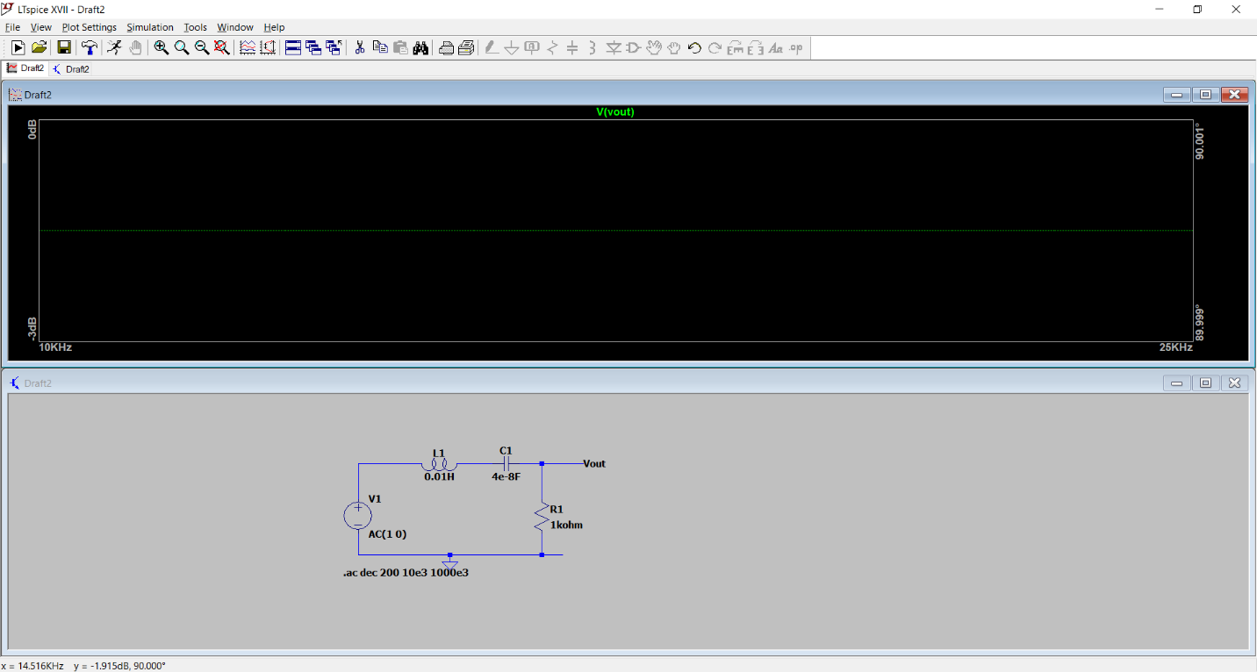

1. In your REPORT, use your knowledge of the low frequency and high frequency characteristics of inductors and capacitors, discuss why your plot makes sense.
   1. The values of the capacitor were solved for using the equations. Since the wanted frequency was given, I was able to calculate for the capacitor value. The plots show that.
2. What is the effect of changing the value of the resistor, while holding the other components constant? Does the resistor affect the bandwidth or the resonant frequency?
   1. If the resistance value changed the only thing that would be affected is the bandwidth because it is used in the formula while it isn’t used in the resonant frequency equation.
   2. **Parallel LRC Circuit**

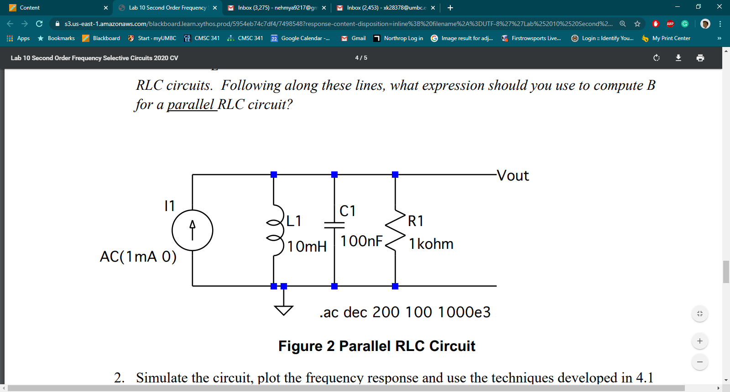

1. Simulate the circuit, plot the frequency response and use the techniques developed in 4.1 to estimate the -3 dB bandwidth of the circuit. Compare your simulated values to the values predicted in 1. Save and print the circuit and print all of the frequency response plots you used in your analysis.
   1. Bandwidth calculated: 10,000 rad/sec Bandwidth measured: 9876 rad/sec
   2. Frequency calculated: 49672.9 Hz Frequency measured: 50264.3 Hz

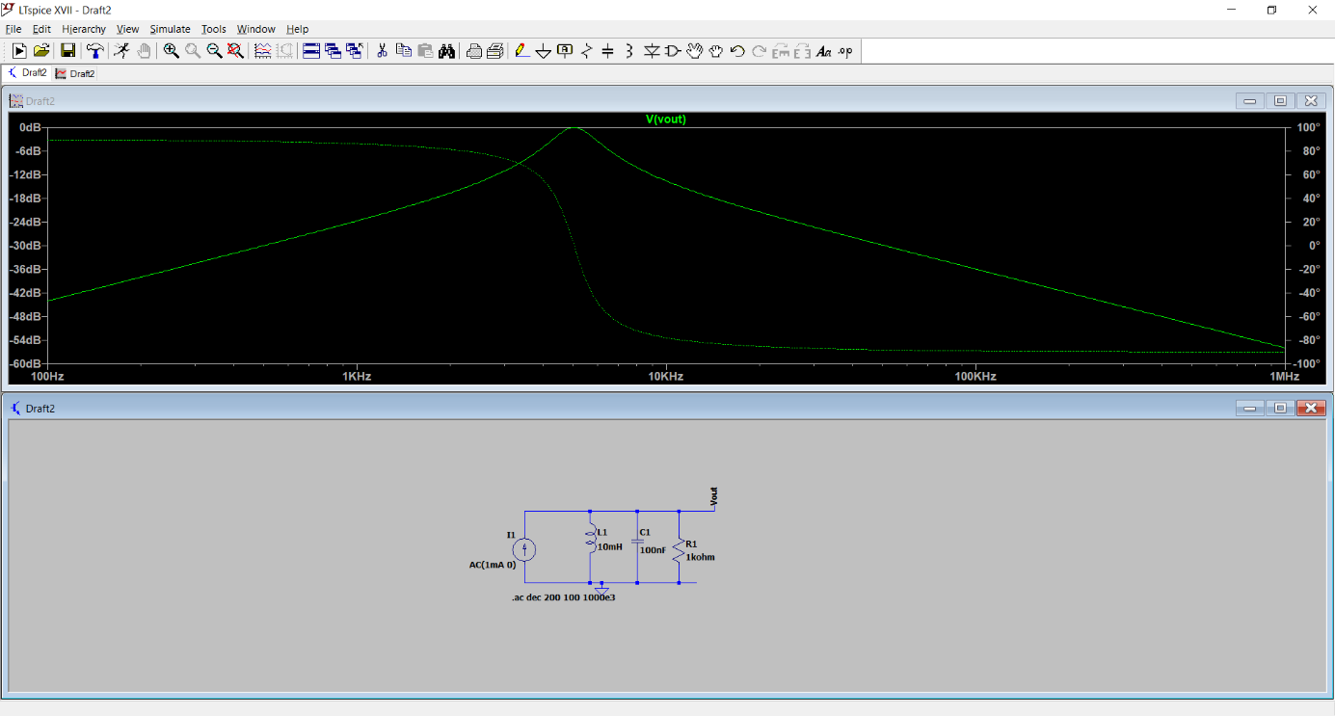

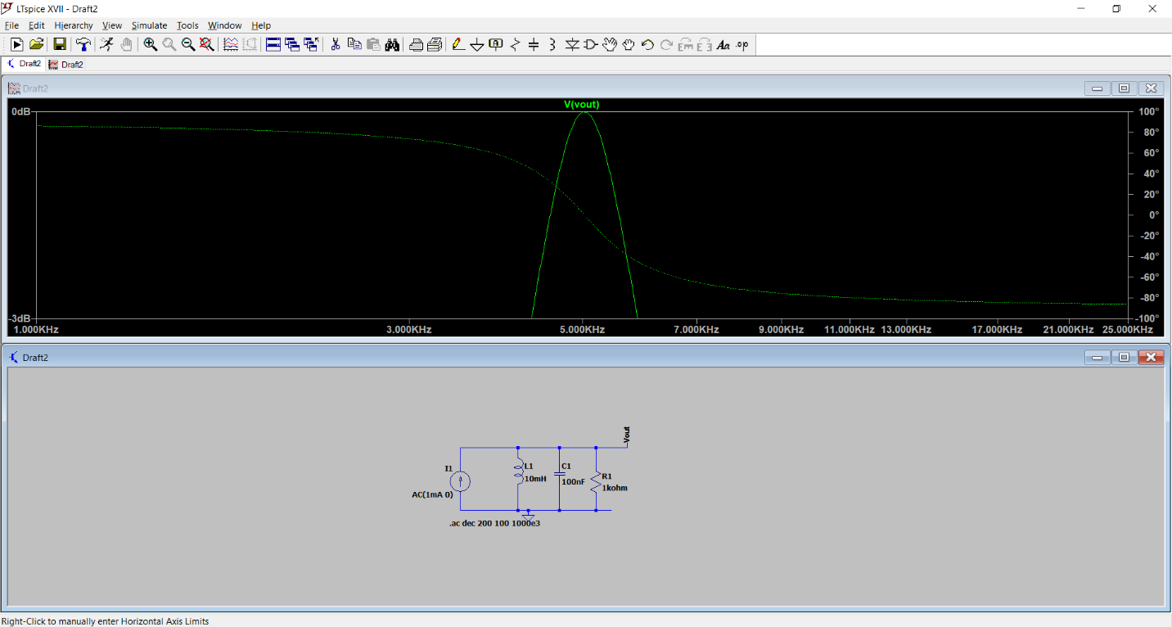

1. Select new values for the components to change the circuit to have the following properties: resonant frequency of approximated 500 kHz and bandwidth of approximately 160 kHz. Hint: You may need to modify the amplitude of the current source to make your resonant peak stay at 0 dB. Save your modified circuit. Simulate your circuit and verify that it meets the specifications. Continue iterating your design until you are within 2% of the desired values, simulating as you go.

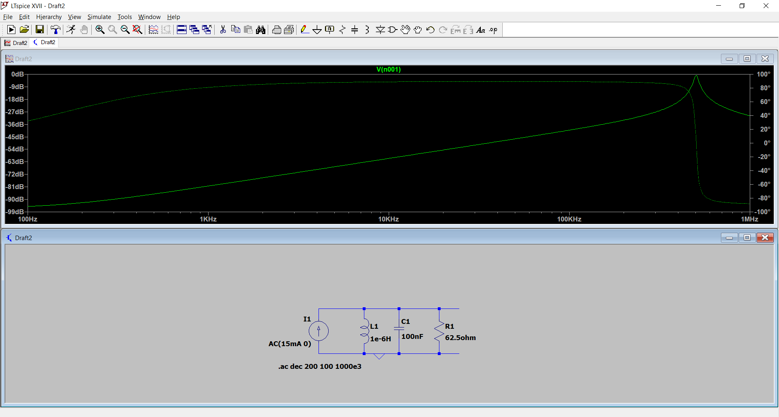

**Conclusion**

The series resistance affects the result inversely, as $w= \frac{1}{\sqrt{LC}}$, so the greater the resistance from the inductor, the lower the resident frequency. The graph of the first circuit shows that the circuit forms a selective frequency filter, or a bandpass filter. Because capacitors create a high pass filter and inductors create low pass filters, combining them would result in a bandpass filter, as the frequencies from the high and low ends are muted. Reversing the orientation of the capacitor and inductor, as seen in the second circuit, gives the opposite effect, as we see all frequencies until a certain point eradicated.